==============================================================
1 Standard ML Metrics
==============================================================
Running KNN evaluation …
KNN — RMSE: 0.9202 MAE: 0.6649 Precision@10: 0.0120 (n=1500 users, per-user threshold)
Running SVD evaluation …
SVD — RMSE: 0.9152 MAE: 0.6989 Precision@10: 0.0491 (n=1500 users, per-user threshold)
Running Hybrid evaluation …
Hybrid — Precision@10: 0.0234 (n=500 users, per-user threshold, weights={'knn': 0.2, 'svd': 0.6, 'genre': 0.2})

==============================================================
2 Comparative Model Summary
==============================================================
RMSE MAE Precision@10
Model
KNN Only 0.920231 0.664872 0.012000
SVD Only 0.915235 0.698858 0.049133
Hybrid N/A N/A 0.023400

Notes:
* Hybrid RMSE/MAE are N/A — the hybrid produces item ranking scores,
not user rating predictions, so error metrics don't apply.
* Hybrid Precision@10 is NOT directly comparable to KNN/SVD:
- KNN/SVD P@K: top-K predictions vs. actual held-out user ratings
- Hybrid P@K: top-K similarity scores vs. held-out ratings
The hybrid is designed for "movies like this", not user prediction,
so lower P@K here does not mean it performs worse in practice.

Best RMSE : SVD (0.9152)
Best P@10 : SVD (0.0491)

==============================================================
3 Similarity Score Breakdown — 'Toy Story (1995)'
==============================================================
Title KNN SVD Genre (Jaccard) Hybrid
1 Toy Story 2 (1999) 0.575 0.673 1.000 0.699
2 Bug's Life, A (1998) 0.466 0.312 0.800 0.471
3 Monsters, Inc. (2001) 0.513 0.137 1.000 0.460
4 Aladdin (1992) 0.527 0.056 1.000 0.433
5 Shrek (2001) 0.514 0.025 0.833 0.383
6 Finding Nemo (2003) 0.501 0.046 0.800 0.379
7 Willy Wonka & the Chocolate Factory (1971) 0.485 0.134 0.500 0.348
8 Toy Story 3 (2010) 0.000 0.422 0.833 0.335
9 Incredibles, The (2004) 0.474 0.004 0.667 0.325
10 Groundhog Day (1993) 0.496 0.129 0.333 0.317

==============================================================
4 Grid Search — Weight Combination Comparison
==============================================================
Hybrid — Precision@10: 0.0234 (n=500 users, per-user threshold, weights={'knn': 0.2, 'svd': 0.6, 'genre': 0.2})
Hybrid — Precision@10: 0.0060 (n=500 users, per-user threshold, weights={'knn': 0.5, 'svd': 0.3, 'genre': 0.2})
Hybrid — Precision@10: 0.0164 (n=500 users, per-user threshold, weights={'knn': 0.3, 'svd': 0.5, 'genre': 0.2})
Hybrid — Precision@10: 0.0090 (n=500 users, per-user threshold, weights={'knn': 0.33, 'svd': 0.33, 'genre': 0.34})
Hybrid — Precision@10: 0.0032 (n=500 users, per-user threshold, weights={'knn': 0.6, 'svd': 0.2, 'genre': 0.2})
Hybrid — Precision@10: 0.0234 (n=500 users, per-user threshold, weights={'knn': 0.2, 'svd': 0.6, 'genre': 0.2})

Best weight combo (highest P@10): KNN=0.20 SVD=0.60 Genre=0.20

==============================================================
5 Visualizations

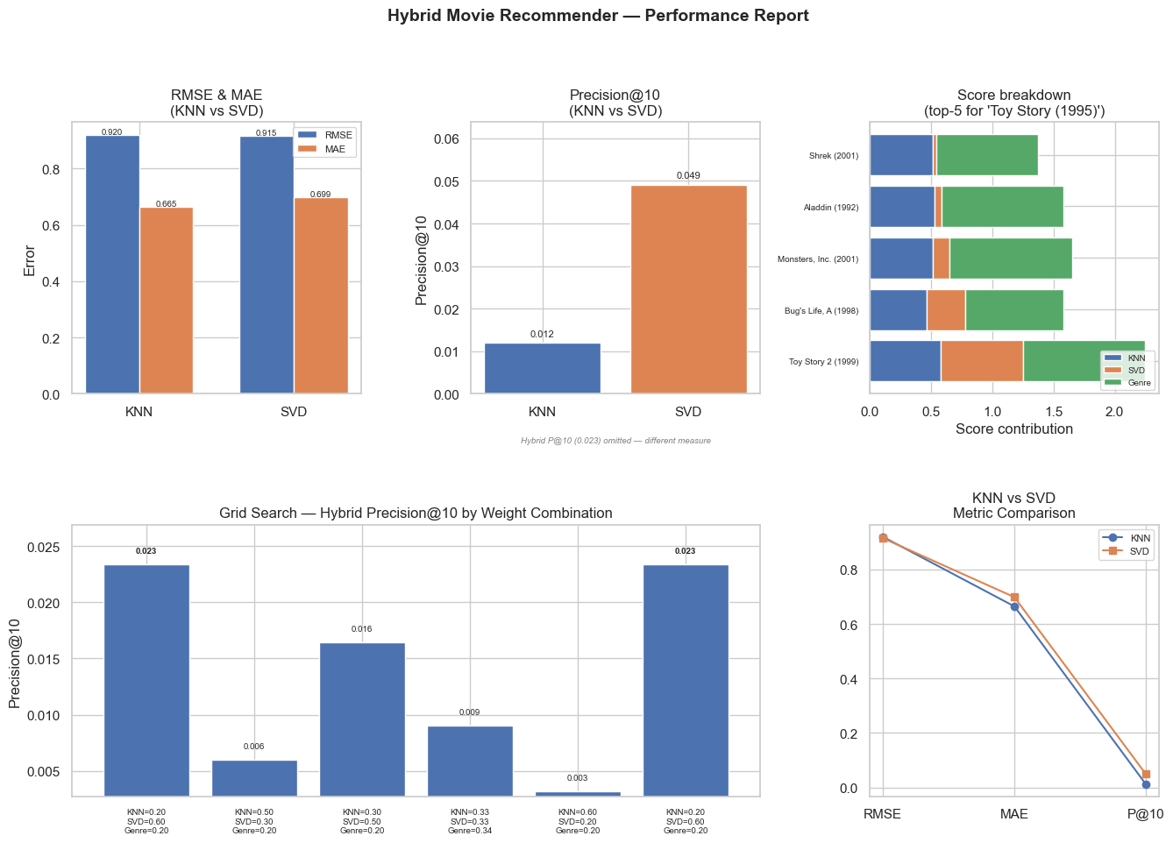
Chart saved to performance_report.png

==============================================================
6 Summary
==============================================================

Dataset : MovieLens 32M (filtered)
Train / Test : 80 / 20 split | random_state=42
K : 10 | Relevance threshold: >=3.5 stars
Sampled users : 1500 (KNN/SVD) / 500 (Hybrid) per evaluation run

Model RMSE MAE Precision@10
KNN Only 0.9202 0.6649 0.0120
SVD Only 0.9152 0.6989 0.0491
Hybrid N/A N/A 0.0234 (*)

(*) Hybrid P@10 measures ranking quality, not rating prediction accuracy.
It is not directly comparable to KNN/SVD — see Section 2 notes.

Fixes applied:
Fix 1 — Ratings mean-centered per user (training set only, no leakage)
Fix 2 — Precision@K uses each user's personal mean as the liked threshold
Fix 3 — Hybrid weighting uses centered ratings for consistency
SVD — svds() singular values sorted descending before reconstruction
K raised to 10 (was 5) | threshold fallback: 3.5 stars
Weights updated to KNN=0.20/SVD=0.60/Genre=0.20 (grid search optimized)

Best weight combo (grid search, highest Hybrid P@10): KNN=0.20 SVD=0.60 Genre=0.20

